St Peter’s Catholic Primary School
Strategic Plan
2015-18

Strategic Plan 2015-2018

What is the Strategic Plan?

The school Strategic Plan gives direction to the school as a whole in implementing its vision and aims. It provides a focus for dialogue about school improvement between the people who work there. It provides a monitoring and self-evaluation mechanism for Governors and the Leadership Team. It gives control over the nature and pace of change.

What We Do:
MISSION
Through loving God, everyone at St Peter’s School is committed to creating a happy loving and secure environment for learning, which has Christ at the heart of its community, where everyone is valued and shows respect for each other.

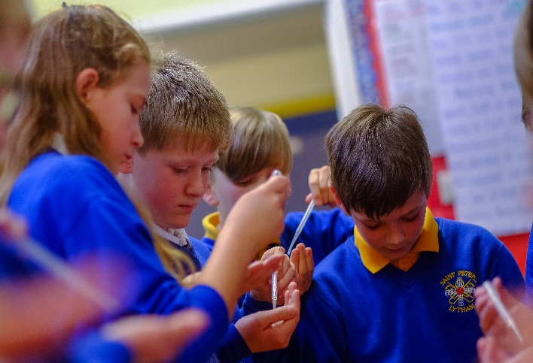
Where We Want to Be:
VISION
St Peter’s Catholic Primary school aspires to be a world-class school that enables all our pupils to reach their potential not just intellectually, but spiritually, morally and socially; as independent and resilient learners aware and confident in their own truly unique qualities and skills. Guided by the example of the Gospels to grow into individuals who make positive contributions to their local and national communities and the world.

What We Believe In:
CORE GOSPEL VALUES
Whilst other ‘values’ may be found within the four Gospels and New Testament writings, it is the Beatitudes which: “…depict the countenance of Jesus Christ and portray his charity” and are the objective ‘values’ given from Christ himself.

“Blessed are the poor in spirit, for theirs is the Kingdom of heaven”
Values: Faithfulness & Integrity
“Blessed are those who mourn, for they shall be comforted”
Values: Dignity & Compassion
“Blessed are the meek, for they shall inherit the earth”
Values: Humility & Gentleness
“Blessed are those who hunger and thirst for righteousness, for they shall be satisfied”
Values: Truth & Justice
“Blessed are the merciful, for they shall obtain mercy”
Values: Forgiveness & Mercy
“Blessed are the pure in heart, for they will see God”
Values: Purity & Holiness
“Blessed are the peacemakers, for they shall be called children of God”
Values: Tolerance & Peace
“Blessed are those who are persecuted for righteousness’ sake, for theirs is the kingdom of heaven. Blessed are you when they insult you and persecute you and utter every kind of slander against you because of me. Be glad and rejoice for your reward is great in heaven; they persecuted the prophets before you in the very same way”
Values: Service & Sacrifice

“I have come that they may have life and have it to the full”

John 10:10

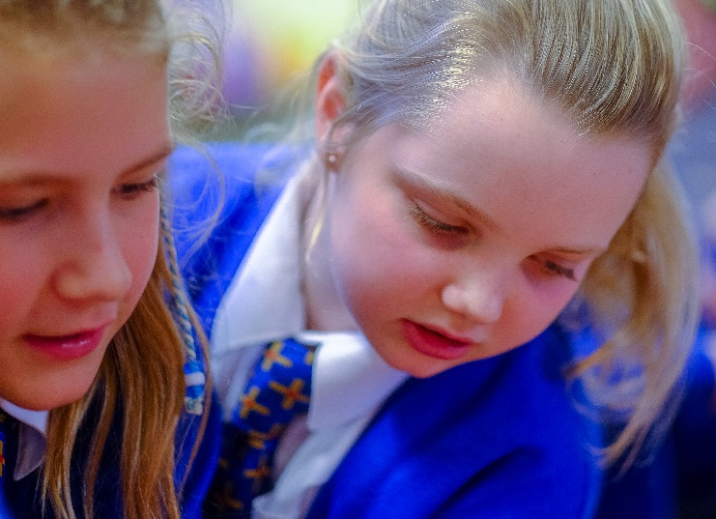
“Jesus is at the heart
of all that we do”

School Motto

Our School Aims:

- To be inspired and challenged by the Gospels and to celebrate in word and action God’s love for us and our love for him.

- To provide a community spirit in which children are happy and made to feel welcome and valued, conscious of their own worth as individuals.

- To prepare children for life-long learning, valuing the uniqueness of every child and providing for their needs within a safe and secure environment.

- To develop active learners with lively and enquiring minds through the establishment of a firm foundation of positive attitudes and skills, and an understanding of themselves as learners.

- To provide an inspiring curriculum which reflects the uniqueness of the Catholic school; built on thematic activities and first-hand experiences, underpinned by the core values of the Gospel.

- To continually strive for excellence in teaching and to offer challenge leading to the highest standards of personal achievement for all our children, where effort is valued equally with attainment.

- To encourage a spirit of friendship and cooperation and promote high standards of behaviour, which reinforces mutual respect, tolerance and understanding of the needs of others, so that each child may learn to live as a member of God’s family world- wide.

- To care for, and to serve those, who have particular needs both within our school and those who are outside it.

- to work in partnership with parents, Governors, parishes and members of the wider community, to involve and inform them, and welcome them to share in the school’s liturgy and prayer life.

What are the main strategy themes/areas?
We will build our strategy around the current areas identified by OFSTED:
- Effectiveness of leadership and management (including Governance, middle and subject leadership)
- Quality of teaching, learning and assessment
- Outcomes for pupils
- Personal development, behaviour and welfare (including pastoral and community links)
Additionally;
- Physical and financial resources (including premises development)

Futures Thinking
What could our school look like in 2020?
Leadership & Management | - Collectively and shared vision for the school  - A collaborative search for excellence  - Middle/subject leaders empowered to lead change  - Governors fully informed and trained in all aspects of school life
Quality of teaching & learning | - A culture of open-mind sets exists  - Outstanding teaching motivates and enables pupils to make sustained progress.  - The curriculum enables pupils to use higher order skills; questioning, evaluating, creating and investigating.  - The new Curriculum is embedded and developed to reflect the needs of St Peter’s pupils.  - Opportunities to deepen understanding and consolidate learning are routinely part of classroom practise.  - Assessment systems are embedded and provide clear indicators of gaps in learning.  - Intervention is continually adapted and designed to have maximum impact upon learning outcomes.  - St Peter’s is a leading school in the locality; teaching school status, EYFS, Forest Schools, approaches to teaching & learning.  - Rich experiences and opportunities exist to develop the whole child  - Facilities and resources allow for excellent teaching and participation in sport, art and music.  - Technology is up-to-date and embedded within the classroom; children use a wide range of devices to communicate, improve, design and research.  - Technology allows for seamless learning opportunities between home and school.
Outcomes for pupils | - Pupils continue to make excellent progress from their starting points.  - Outcomes build upon previous high standards  - Pupils attainment remains significantly above national expectations
Personal development & welfare | - Children are more independent and understand their own needs as learners  - There are strong links with other schools locally, nationally and internationally  - Communication with parents is excellent; parents feel fully informed regarding their children’s progress and attainment  - Parents are given opportunities to develop knowledge and skills to support their child in their learning.
Premises & Resourcing | - The building in significantly updated; 21st century learning environment.  - The building is fit for purpose in terms of capacity and repair.  - Areas of the building are re-modelled/extended to ensure maximum use of footprint  - The buildings are in good decorative repair and provide additional storage  - Development of outdoor space; including greater access to continuous outdoor provision; sporting facilities; eco-classroom?  - St Peter’s is extended to ensure that growing number of Catholic families are able to access a Catholic education for their children? (Evidence of need would have to be provided before this would be considered)

What We Want to Accomplish:
GOALS
1. That the RE Curriculum is reviewed to ensure greater depth of study on areas of Catholic social teaching and is a foundation for all other learning.
1. Continue to ensure that all pupils make excellent rates of progress by providing rigorous, engaging and relevant learning experiences which allow for consolidation and depth of understanding.
2. Improve standards in pupil’s writing: that pupil’s writing skills are developed to a high standard and commensurate with reading;
3. Improvement of pupil’s independence & involvement in their learning; Children use higher order skills; questioning, evaluating, creativity and investigation. Children demonstrate resilience, communicate effectively and cooperate with each other.
4. Maintain a focus on developing exemplary teaching and sharing expertise throughout the local community.
5. Improvement in the quality of ICT provision: that the school’s infrastructure effectively supports the smooth running of the school and plays an integral part in teaching and learning.
6. The premises to be updated significantly to ensure that it continues to be fit for purpose in terms of capacity and teaching and learning in the 21st Century.
7. To enhance Assessment for Learning processes within the classroom; to develop a whole school approach to assessment without levels.
How We Will Achieve Our Goals:
STRATEGIES
1. Focus on every child, in every classroom, every day: Support an approach to teaching and learning that is responsive to each pupil’s academic, social, and emotional needs.
2. Invest in our educators: Sustain the high quality of our teachers and support staff by maximizing opportunities for professional development and collaboration.
3. Further enhance the curriculum by including 21st century skills and developing the Curriculum to allow Children to be increasingly more independent in learning through exploring and leading on pedagogical approach with proven evidence of successful impact.
4. Align resources with educational needs: Align resources to accomplish the goals outlined in the Premises Development/ICT Action Plans.
5. Work in collaboration with partner schools to develop and moderate new assessment systems to ensure high standards.

How We Will Assess Progress on Our Goals:

MEASURES OF SUCCESS
Rigorous Self-evaluation is the cornerstone of school improvement and is a continual and continually revealing process. It is ‘a window through which others see the school. But it is also the mirror through which the school sees itself as others see it’. School Self-evaluation:

- Provides a clear and un-bureaucratic framework for self-review
- Places pupil progress and attainment at the heart of the process
- Leads to a rigorous and objective diagnosis of need
- Leads to effective improvement planning to build on the school’s strengths and remedy existing weaknesses.

