ADRIENNE MAKIN BA,ALCM,PGCE

C:\Documents and Settings\manager\Local Settings\Temporary Internet Files\Content.IE5\CUUL32FD\MC900319312[1].wmf C:\Documents and Settings\manager\Local Settings\Temporary Internet Files\Content.IE5\H1KJ1IH9\MC900435336[1].wmf C:\Documents and Settings\manager\Local Settings\Temporary Internet Files\Content.IE5\QE37JV0C\MC900390668[1].wmf

PIANO, SAXOPHONE, CLARINET, FLUTE, RECORDER, THEORY.

ABRSM EXAMINATIONS

RING 01253 735380

44, WEST CLIFFE LYTHAM

JOHN FRANCIS PHOTOGRAPHY

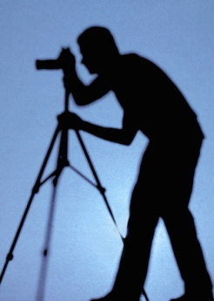 [www.johnfrancisphotography.co.uk](http://www.johnfrancisphotography.co.uk)

5 Hastings Place Lytham FY8 5LZ

07973 224466

John.francis27@btinternet.com

Solicitors & Notaries

Commissioners for Oaths

Mary E. Lowe LLB (Hons)

Partner

33 Church Road, Lytham, Lancashire,

FY8 5LL

**Tel: 01253 730086**

Email:mlowe@blackledgesolicitors.co.uk

www.blackledgesolicitors.co.uk

Highly Effective

RELAXING Techniques using Hypnotherapy-NLP-EFT

CALL JOAN NOW

01253733926/ 07809723362

Lytham Lancs FY8 4LP

One2one-groups-business

[Joan.short@able2change.co.ok](mailto:Joan.short@able2change.co.ok)

[www.able2change.co.uk](http://www.able2change.co.uk)